LEGO BUSINESS MODEL

- LEGO's Business Model
  - Explanation of LEGO's core business model
  - Revenue streams (e.g., sales of sets, licensing, merchandising, etc.)
  - Unique aspects of the LEGO business model

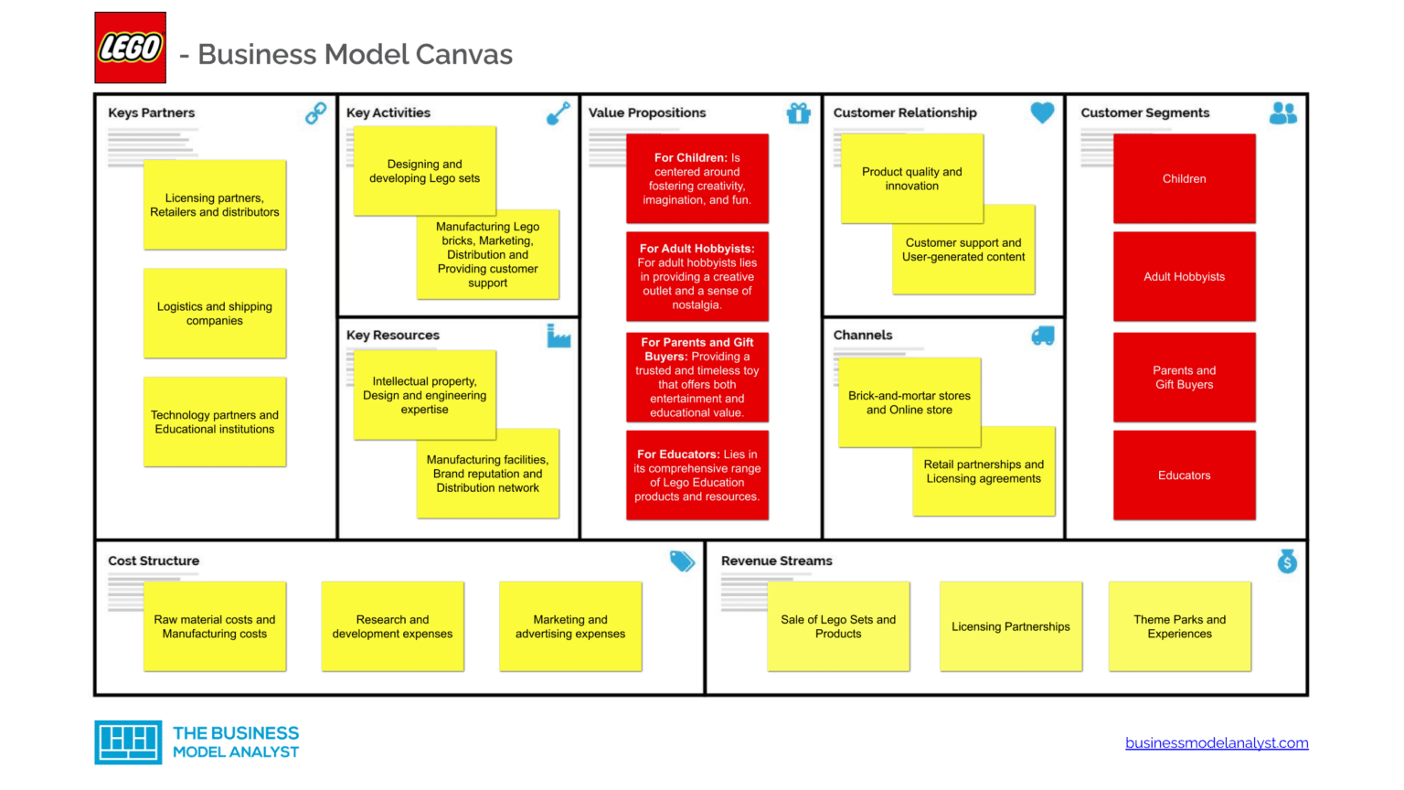
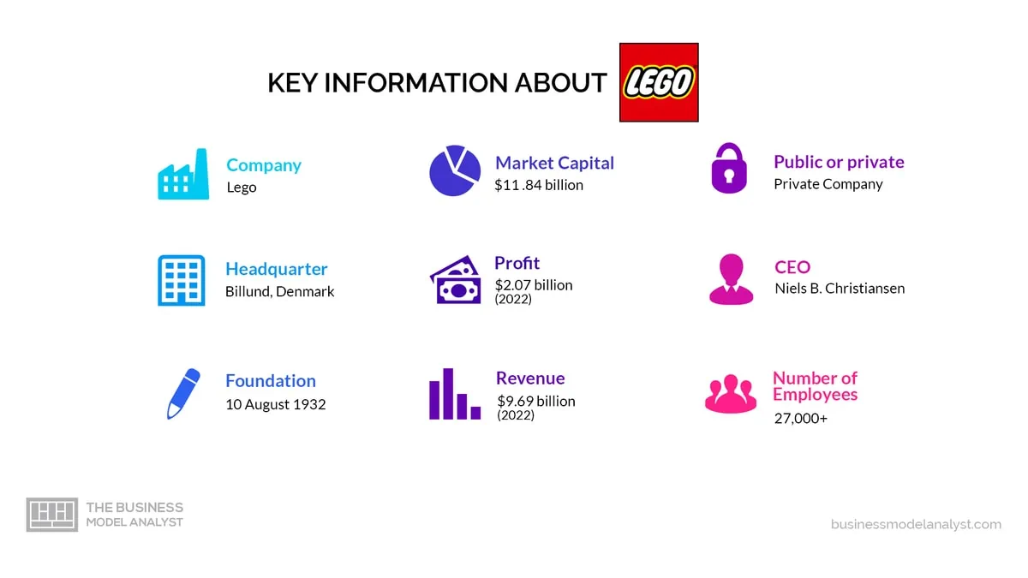

CORE BUSINESS MODEL

LEGO® Group is a very successful toy production company, with a successful business model and ability to take on new profitable opportunities and improve.
Its market value increased from $5.4 bln in 2015, to approximately $13 bln in 2023.
Its success allows it to reap outstanding profits: in 2023 the year closed with DKK 65.9 billion ($ 9,52 bln ) revenues, and DKK 17.1 billion ($ 2.47 bln) in operating profit.
The revenues are the result of a vast differentiation in offer and a big market share. More details later on,

LEGO® Group is present in more than 130 countries, owns more than 570 stores and 5 manufacturing plants.

The business can be summarized as follows:
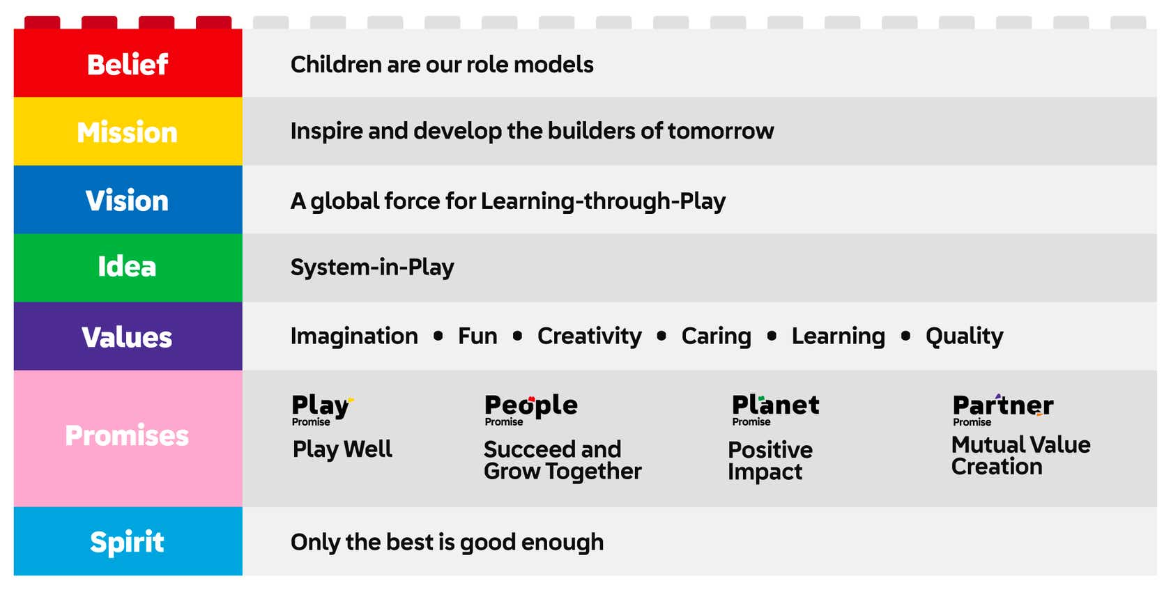

Lego’s commitment to remaining privately owned allows the company to focus on its long-term vision and values, without the short-term pressures often associated with public ownership. This has enabled it to maintain its status as a global leader in the toy industry while staying true to its core principles of creativity, quality, and learning through play

KEY STRATEGIES
Its success is based on these key strategies:

- QUALITY:
Lego has built the reputation of offering durable and safe toys, focusing also on the highest playability standards.
- BRAND IDENTITY:
Lego’s has managed to transmit to people the link between its brand and its key values: imagination, fun, creativity, caring, learning and quality.
- GLOBAL REACH:
LEGO is present in more than 130 countries thanks to its variety in the distribution channels. To attract customers from different countries, it adapts to local preferences and cultural nuances
- PARTNERSHIPS and COLLABORATIONS:
LEGO has found that making strategic partnerships and collaborations with popular entertainment franchises is a great way to increase revenues.
It brings excitement to its already customers, and attracts new ones.
Some popular collaborations are: Disney, Warner Bros, Universal Studios.
- SUSTAINABILITY AND ENVIRONMENTAL RESPONSIBILITY
With the rise in awareness over environmental issues, sustainability has become a key goal for companies. A recent study led by CGS, shows that 68% of consumers rate sustainability as an important factor when making a purchase.
LEGO puts importance to both environmental sustainability, for example it is committed to reduce carbon footprint, use renewable energy sources, eco-friendly packaging.
But also to sustainability in a sense of leaving a good impact on the community and treating its workers fairly.
In this way their brand resonates with conscious consumers
- DIGITAL INNOVATION
With the introduction of digital elements, it managed to survive and thrive in the changing market of play. It developed video games, mobile apps, augmented reality experiences and also films

REVENUE STREAMS

Lego has had a trend for increasing revenues.
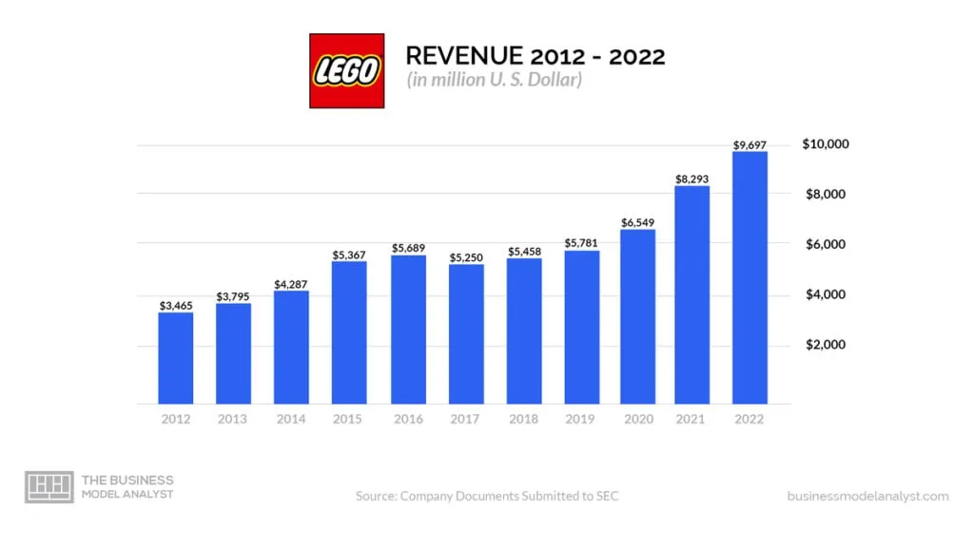

They generate their revenue through:

PRODUCT SALES
Primary revenue stream. Extensive product portfolio and wide customer base.
- LICENSING AND PARTNERSHIPS
These collaborations allow Lego to create specialized sets based on movies, TV shows, video games, and other intellectual properties

- THEME PARKS AND EXPERIENCES
Example Legoland and Legoland Discovery Centers. Revenues from ticket sales, merchandise, food and beverage sales contribute to revenue

- DIGITAL GAMES AND MEDIA
Video games, lego-themed, animated movies, TV shows, web series.
Revenue from sale of these products and licensing fees and partnership with media platforms

- EDUCATION AND LEARNING SOLUTIONS
Promotes learning through play, sets used in school and educational institution to enhance STEM education.

Their customers can be grouped in these categories:
- Children: highest section
- Adult hobbyist, usually collect most intricate sets and focus on expert-level creations, large-scale models, architectural sets
- Parents and gift buyers: because they have a wide range of sets, from affordable to intricate choices
- Educators
- Retailers and distributors

MARKETING
Of course to successfully sell the products and retain customers, a good marketing is needed.

- Iconic partnerships
- User generated content: Lego actively encourages users to generate content, and submit their own designs.
This fosters sense of ownership and excitement in the client’s mind.
Nevertheless it contributes to innovation
- Immersive brand experience, for all ages, such as Legoland and interactive stores.
Helps to deepen emotional connection with customers
- Emotional storytelling: use “heartwarming” commercials and campaign, and storytelling competitions to tap on nostalgia and reminding customers of the joy of the brand
- Engaging digital campaigns: example building challenges
- strong partnerships with educational sector
- Pricing strategy: strikes a balance between value and perceived quality.
It has an higher price tag that reflects the quality and the craftsmanship
- Strong presence in social media platforms

COST STRUCUTRE

Lego’s cost structure consists of:
- Raw material costs
- Manufacturing costs
- Research and development expenses
- Marketing and advertising expenses
- Distribution and logistics costs
- Licensing fees
- Administrative and operational expenses
- Customer support costs

LEGO 2000s MANAGERIAL CHANGE
https://knowledge.wharton.upenn.edu/article/innovation-almost-bankrupted-lego-until-it-rebuilt-with-a-better-blueprint/

https://www.cfocentre.com/us/true-toy-story-legos-incredible-turnaround-tale-2/

Revenues haven’t always been so flourishing. Indeed between 1990 and 2000 Lego almost went bankrupt.
By 2003, the company was virtually out of cash. It lost $300 million that year, and the projected loss for the next year was up to $400 million.
To get out from this they learned that innovation is key, but it has to have direction.
Indeed they already had a lot of creativity and had expanded a lot the range of products offered, but they found out later that only a few of their creative ideas were actually making money.
Actually at the time the company had no idea which products were making money.
Even the success of Harry Potter line wasn’t enough to cover the losses made by that point.

The company had yet to answer these basic questions:
“Where do you want to go?”, “Where are you now?” and “How will you get there?”

SOLUTIONS

To solve the issue, the former CEO Kirk Christianses left the chair to Knudstorp.
With the help of Finance Director, Jesper Oveson (former Chief Financial Officer of one of the largest banks in Scandinavia, the Danske Bank), Knudstorp began to make sweeping changes.

Some of the key issues identified were:
- inadequate degree of financial analysis
- profit and loss by country but not by product => no product analysis and profitability of lines
- theme parks were a cash drain, but they didn’t know why

Some of the key solutions:
- Setting financial targets. Ovesen introduced a near-term, measurable goal of 13.5% return on sales benchmark and established a financial tracking system—the Consumer Product Profitability system. It measured the return on sales of individual products and markets so the company could track where it was making and losing money. Every existing or proposed product had to demonstrate it could meet or surpass that benchmark.
- Cost-cutting (including cutting 1,000 jobs)
- Improving processes (many processes were outsourced which meant employee numbers could be cut by another 3,500)
- Managing cash flow
- Introducing performance-related pay
- Reducing the product-to-market time.
- Selling the theme parks and slowing retail expansion.
- Cutting the number of components from almost 7,000 down to about 3,000
All of this allowed Lego to survive this period of crisis and go back on track stronger than before

LEGO AGILE TRANSFORMATION

https://www.dockconsulting.nl/wp-content/uploads/2021/03/Agile-at-Lego.pdf

INTRO
Lego group noticed that the modern environment is one where innovation and ability to adapt quickly to changes is an essential skill.
They were already aware of this, as the past taught them, and that’s also why they have developed an interest in the agile method of leading an organization.
Some of the principles taught from the agile method were already at use at Lego.
But the real change was made in 2018, when they launched an Agile transformation of the corporate digital departments.
The benefit they were seeking to obtain, was to increase their responsiveness in both IT and product development. And indeed they have obtained many benefits.
What is the agile model?
Any so-called “agile processes' ' adheres to the Agile Manifesto ( Beck et al. 2001). The Agile Manifesto is not a methodology, but rather a mind-set, a way of thinking that supports certain behaviors. The Manifesto is a list of 12 principles, which emphasize customer engagement, flexibility, collaboration, and rapid delivery of working products.

CHANGES TO TAKE
When an organization wants to adhere to an agile model, there are some key changes that have to be taken:

• Organizational structure—Evolve from existing structure (such as functional or matrix) to a product-oriented team structure.1
• Mandate—Shift mandate and ownership of deliverables within the strategic frame from managers to product teams.
• Financial processes—Move from traditional yearly budgeting processes (fixed) to frame-based dynamic budgeting (venture-capital style) based on strategic aims.
• Performance measures—Redefine from traditional key performance indicators (KPIs) or similar measures that focus on process adherence to value measures, product
measures, and team measures.
• Delivery processes—Change from end-of-project delivery based on specifications to continuous delivery in iterations based on value added.

Also a change management approach is needed.

To apply an agile organizational structure change, it shouldn’t be done through a top-down change management approach, nor should it be done through a bottom-down change management approach.
The first one is against agile principles, because it would imply telling workers what and how they should do, instead of empowering them. The second approach instead lacks direction.

So to apply this big change, they have followed the Open-Source theory, which offers a middle-way.
In this method employees are not told what to do. Instead they are called to make a change for the benefit of the company.
This approach improves change efforts and reduces the time it takes, because it spares the time that employees wait to be told what to do.

LEGO STRATEGY

Lego’s strategy to implement this change looked like this for the first 100 days:
training, proactive knowledge sharing, leadership and people processes, and value management.

Training included Agile basic training, Scrum master training,
product owner training, Agile leadership training, and Agile coach training.
• Knowledge sharing included social media activities; Agile hub activities; self-organized Agile networks for Scrum masters and product owners, called guilds; and biweekly
Agile meetings with specific topics or guest speakers.
• Leadership and people processes included exploring the need for new job structures and leadership processes. This work is still ongoing in the second half of 2018, as the
company adjusts structures to make Agile roles attractive and relevant to the right people and to ensure all members have an appropriate mandate, for instance, that product
owners really have full product responsibility including, for example, financial responsibility.
• The value management stream focused on establishing product definitions and new performance management structures.

The agile transformation team took a central role in supporting and guiding the transformation.

ORGANIZATION CHANGES

The changes at organizational level can be summarized as:
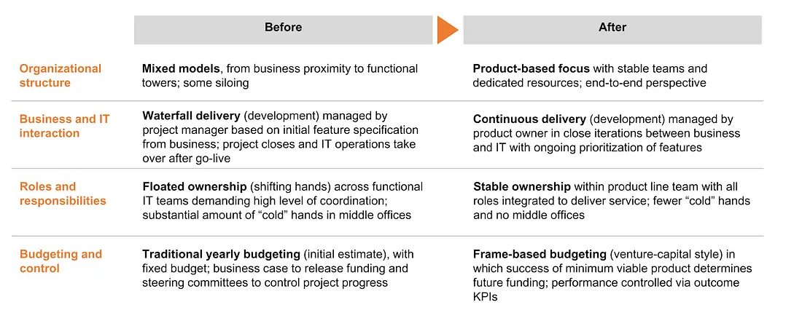
One challenge that the agile transformation brings, is understanding how leaders can best support employees without interfering too much.
Another challenge is that in certain teams the agile method is not needed and doesn’t make the work procedure more efficient.
The teams which struggled seemed to be those whose members had a diverse set of individual responsibilities to a broad range of customers.

LEGO RESULTS
The results at lego were indeed positive.
Agile transformation in LEGO’s two large digital departments has improved responsiveness of digital deliveries, and early results show significant improvement in speed of response to change in many areas, from market engagement to digitalization in production. Project delivery time has been reduced from months to weeks compared to the traditional
development approach. But perhaps most importantly, the new way of working has improved motivation and satisfaction among employees in the two departments that kicked
off the Agile transformation—contributing to a significant positive increase in the yearly employee motivation and satisfaction survey score.

challenges
https://www.planview.com/resources/articles/disadvantages-agile/

LEGO ORGANIZATIONAL STRUCTURE

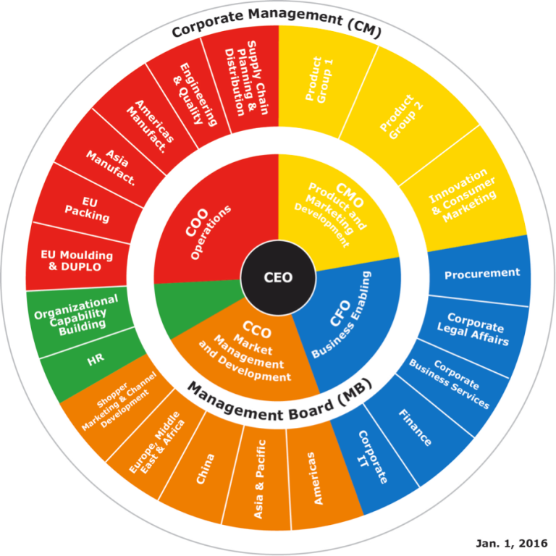

The organizational structure that LEGO® uses which best suits them is the functional structure. Basically, the company has different departments to which they have delegated people to, and heads of that department according to the function. Some of these departments are Sales, Accounts, product development etc
LEGO® being based in so many countries uses a divisional structure which consists of three segments, and these are market, product and geographical.

